**Happycandidate Project Installation Instructions**

1. **Project Installation Steps (Happy Candidate):-**

**Step 1:-** Go to happycandidate folder then open app folder then open config folder then edit core.php file. See below screenshot.

**Happycandidate -> app -> config -> core.php**

http://www.rothrsolutions.com **these links needs to point to** your domain link**.**

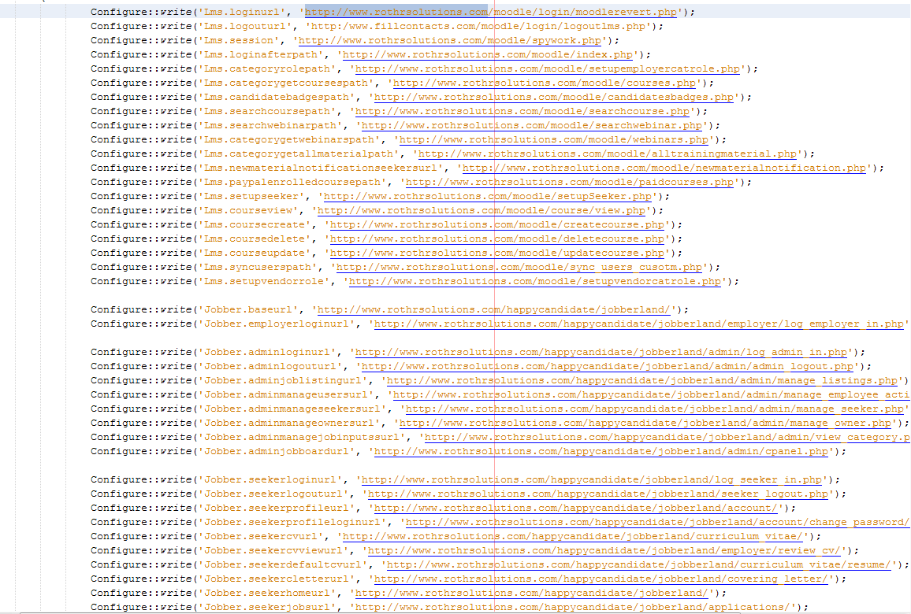

**Step 2:-** Go to happycandidate folder then open app folder then open config folder then edit database.php file, see below screenshot.

**Happycandidate -> app -> config -> database.php**

Change database name, login, password in default section in database.php file.

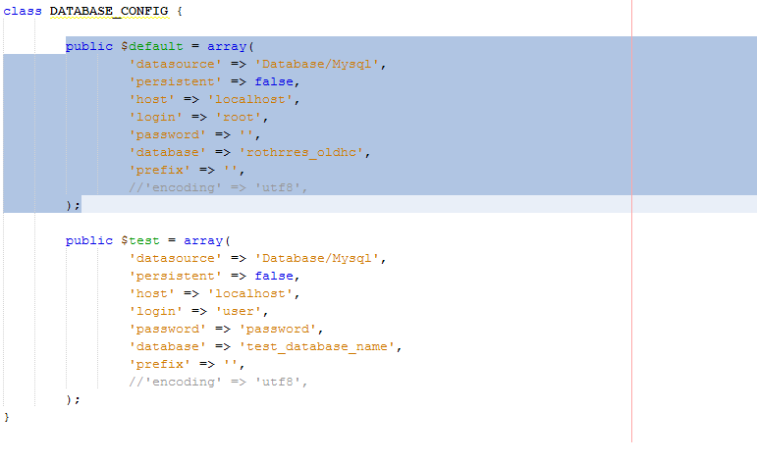

**Step 3:-** Goes to happycandidate folder then open app folder then open config folder then edit email.php file. See below screenshot.

**Happycandidate -> app -> config -> email.php**

Check below changes in default section in database.php file.

1. Default ( From Email Address)
2. Smtp (Username,Password)

